Gabon

## Respect for rule of law (ROL) data

The data set shows the data on the respect of the rule of law for the country.

## # A tibble: 19 x 5  
## country iso3c date ruleOfLaw ruleOfLawCategory4   
## <chr> <chr> <dbl> <dbl> <chr>   
## 1 Gabon GAB 1996 -0.653 ROL moderately disrespected  
## 2 Gabon GAB 1998 -0.353 ROL moderately disrespected  
## 3 Gabon GAB 2000 -0.206 ROL moderately disrespected  
## 4 Gabon GAB 2002 -0.224 ROL moderately disrespected  
## 5 Gabon GAB 2003 -0.370 ROL moderately disrespected  
## 6 Gabon GAB 2004 -0.516 ROL moderately disrespected  
## 7 Gabon GAB 2005 -0.450 ROL moderately disrespected  
## 8 Gabon GAB 2006 -0.737 ROL moderately disrespected  
## 9 Gabon GAB 2007 -0.702 ROL moderately disrespected  
## 10 Gabon GAB 2008 -0.627 ROL moderately disrespected  
## 11 Gabon GAB 2009 -0.546 ROL moderately disrespected  
## 12 Gabon GAB 2010 -0.517 ROL moderately disrespected  
## 13 Gabon GAB 2011 -0.461 ROL moderately disrespected  
## 14 Gabon GAB 2012 -0.469 ROL moderately disrespected  
## 15 Gabon GAB 2013 -0.540 ROL moderately disrespected  
## 16 Gabon GAB 2014 -0.509 ROL moderately disrespected  
## 17 Gabon GAB 2015 -0.550 ROL moderately disrespected  
## 18 Gabon GAB 2016 -0.605 ROL moderately disrespected  
## 19 Gabon GAB 2017 -0.676 ROL moderately disrespected

## Respect for rule of law (ROL) trend

The plot shows the trend of the respect for the rule of law for the country.

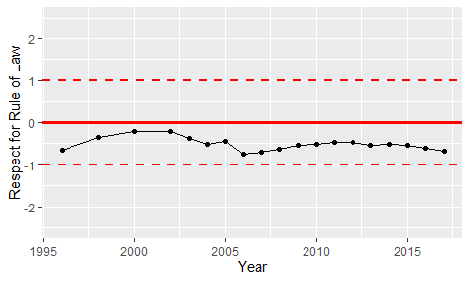

Trend of the Respect for the Rule of Law